Picture Guide
Pictures are to be 4x6 HEADSHOTS with Legal Name and top two choices under it, if applicable.
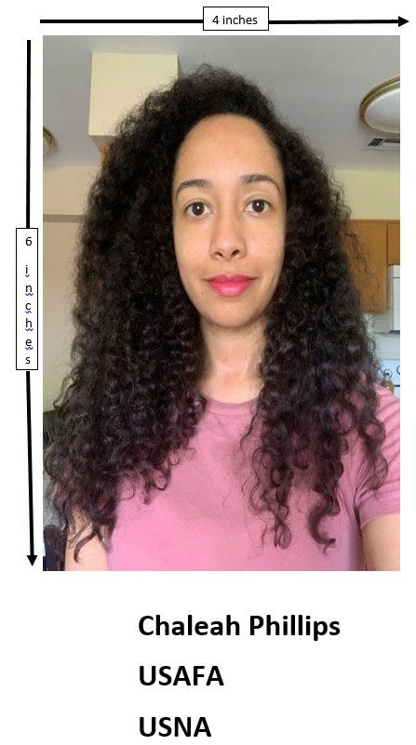

If the Pictures are not the correct size or not a head shot, there are a few ways to fix them:

- Computer:

Right-click the image and save in the Pictures folder in This PC

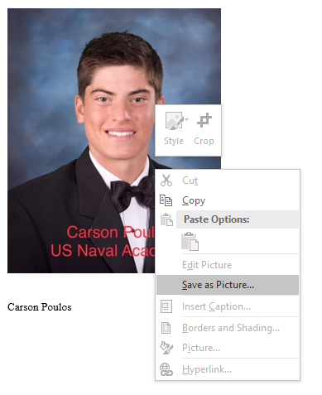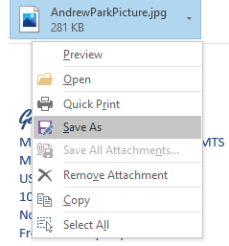

  - If pic is a headshot but the incorrect size, right click the pic you already saved.
    - Click Print on the dropdown menu
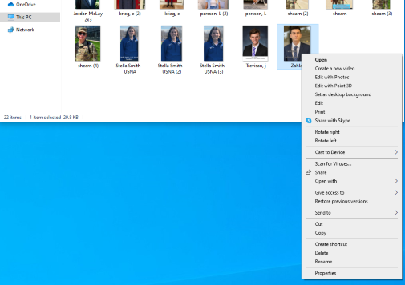

      - A window will open, click the 4x6 on the right and Print
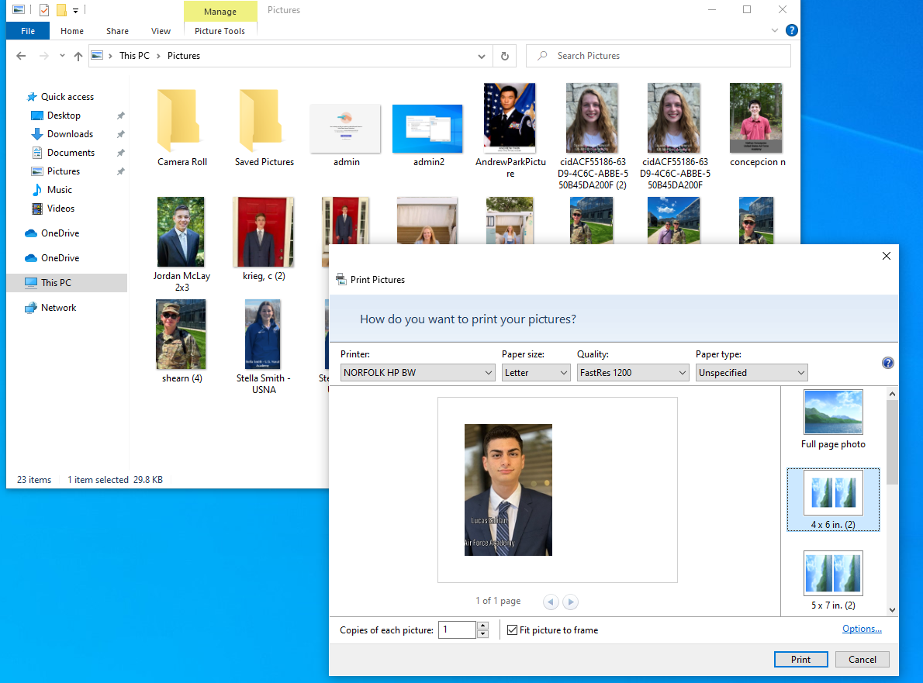

  - If the image is not a headshot or requires editing, double click on the pic to open it in Pictures
    - If the picture requires cropping, click the icon that has a drawing and a pencil above your picture
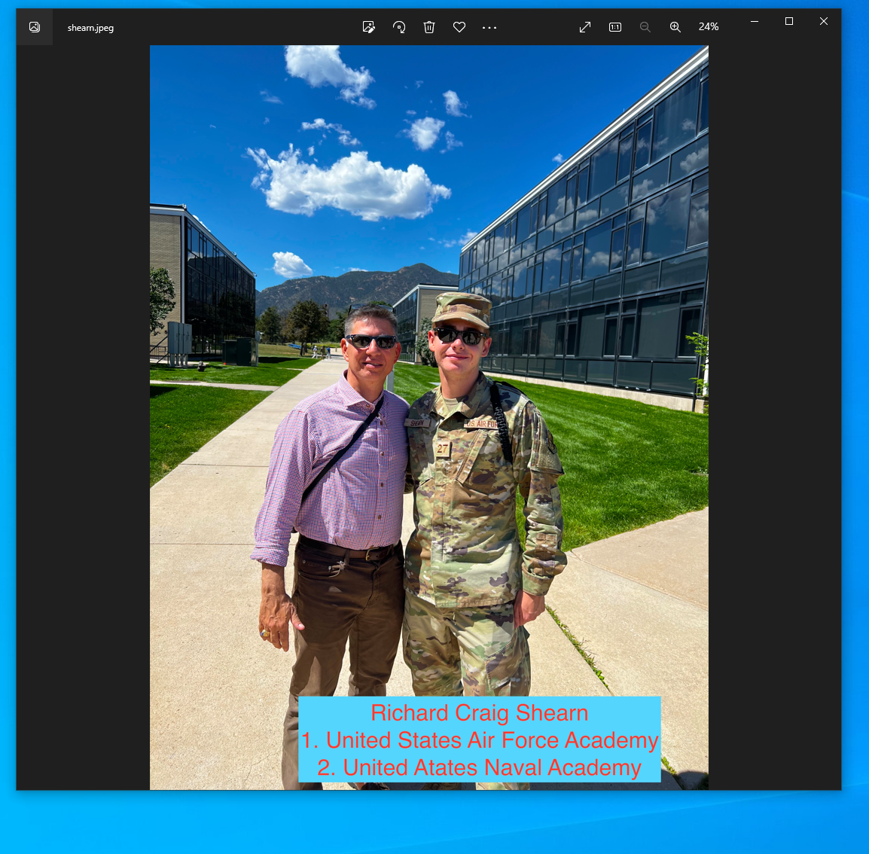

      - The Cropping Icon will appear above, cut what needs to be removed and save pic.
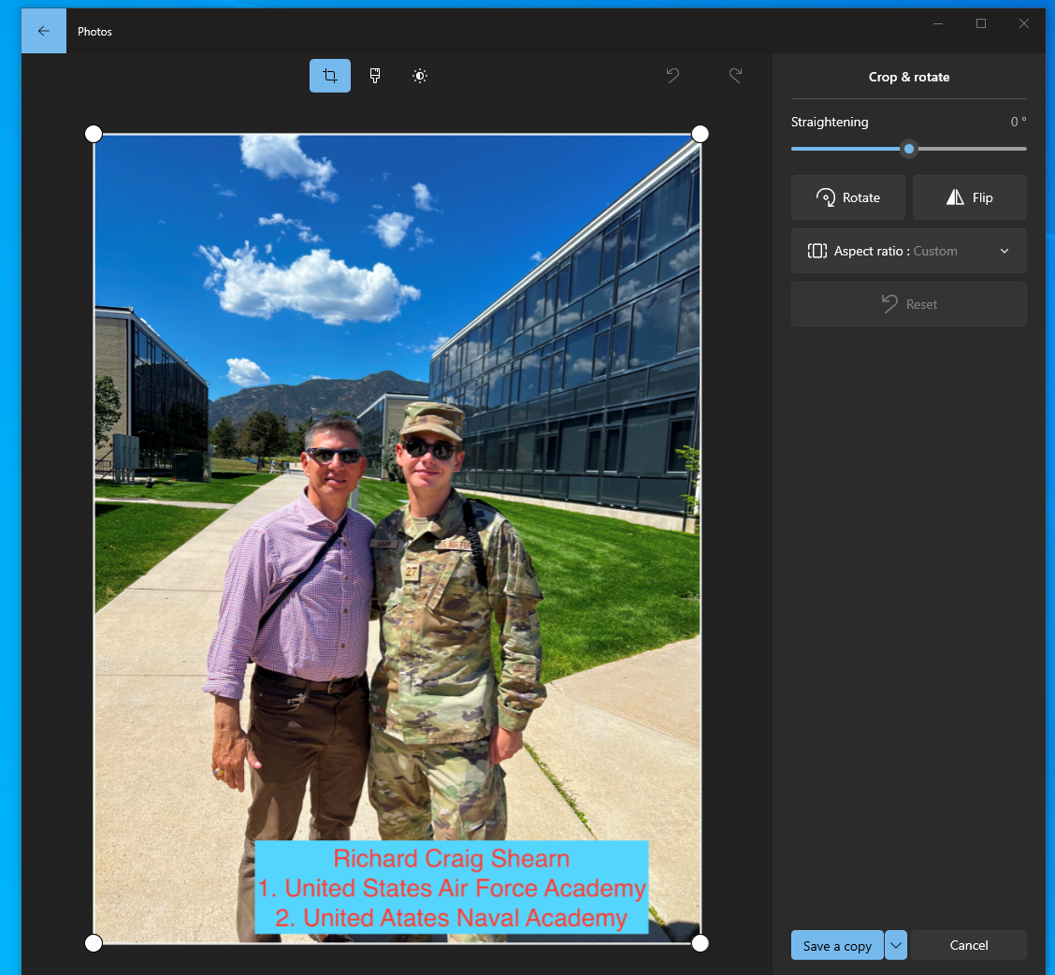

        - Follow steps in a. If the image is too degraded, try it with the Printer steps below. **Please keep in mind that the image may not be adjustable without being compromised.

  - If the image is not a head shot or requires editing, copy/paste pic to Word.
    - Cropping (prior to Resizing): Right click image and select Crop
    - RESIZING: Right click the image and select Format Picture on the drop down menu.
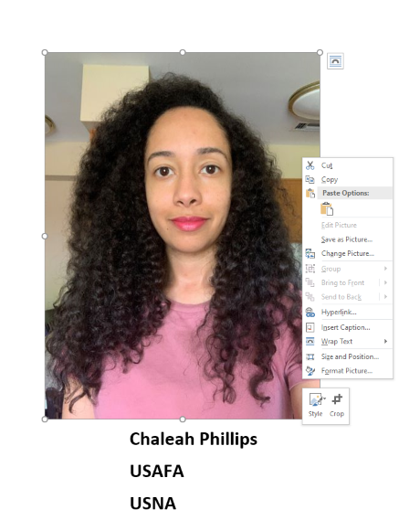

      - Click on the Picture icon in the pop-up menu. Under Crop, make sure the image will be 4x6 with height and width. The numbers will be switched if the original photo was pasted horizontally.
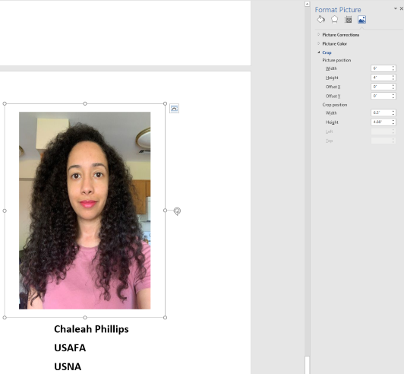

  - ONLY do this step if a., b. c. or Printer steps produce a degraded image. If resizing is required, open the image with Pictures. Right-click, chose Resize.
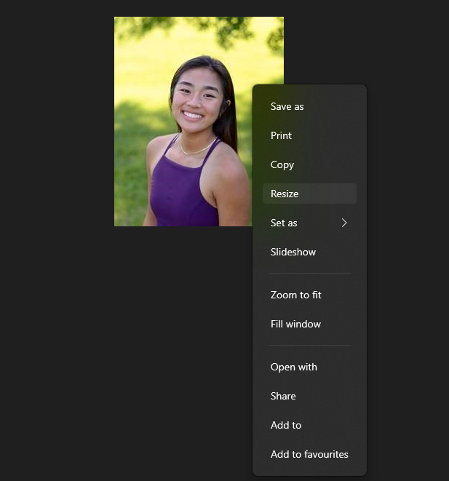

    - Click Define Custom Dimensions
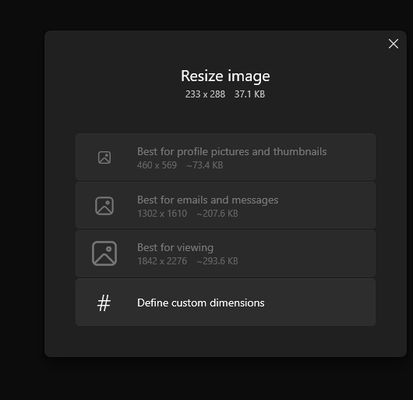

    - Type in 450 into the first box and click Save Resized Copy.
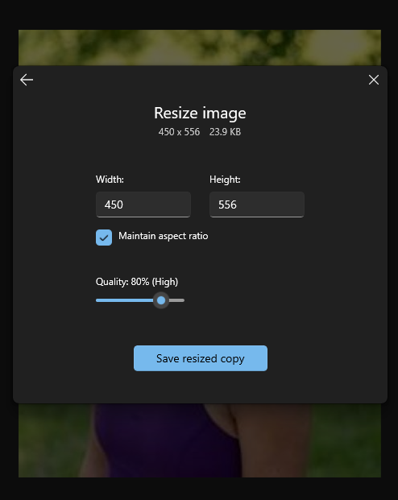

    - Follow step a. If the image is too degraded, try it with the Printer steps below. Please keep in mind that the image may not be adjustable without being compromised.

  - If there is only a paper copy of the pic scan it to your email and utilize steps a., b. or Printer steps, as necessary.

- Printer:
  - Put image face down on printer. Click Copy.
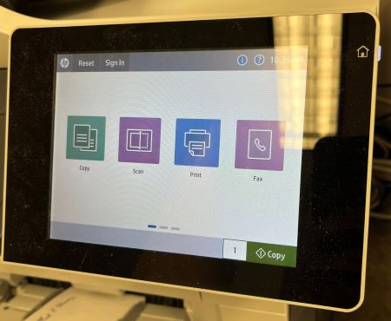

  - On bottom left corner, click Options.
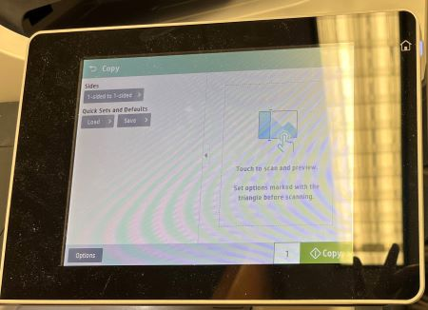

  - On dropdown menu, click Reduce/Enlarge. Adjust as necessary; if image was an entire page, set it to 60%. If the original image was small and the enlarged version is too degraded, try it with the Computer steps above. Please keep in mind that the image may not be adjustable without being compromised.

